Eventi
Use Case Specification

Submitted to:

Asst. Prof. Ma. Rowena C. Solamo
Faculty Member
Department of Computer Science
College of Engineering
University of the Philippines, Diliman

Submitted by:
Dimaano, Aaron Diego I.
Lopez, Matthew S.
Torres, Jacob Angelo V.

In partial fulfillment of academic requirements
for the course
CS 191 Software Engineering I
of the
1st Semester, AY 2015-2016
Unique Reference:
The documents are stored in https://github.com/Tom-2013-06417/CS191-192_Event_Sharing/tree/master/02-Requirements%20Engineering.
Link to this document:

Document Purpose:
The purpose of this document is to exhaust the step-by-step process of the Use Cases in every scenario possible. In this case, this document’s purpose is to show how the users would report wrong content or possibly offensive material inside the website domain.

Target Audience:
To our project client and adviser, our fellow 191 classmates, and our future selves when they need to refer back to this document.

Revision Control:

Revision Date | Person Responsible | Version  Number | Modification
09/18/15 | Dimaano, Diego  Lopez, Matthew  Torres, Jacob | 1.0 | Initial Document

Use-Case Name: Report wrong / offensive content

Description: This feature catalyzes the improvement of the site. By allowing users to provide feedback, administrators can manage the information coursing through the site. This functionality also allows people to point out points for improvement, which include, but are not limited to, bugs, typos, and grammatical errors within the site.

Preconditions: There is an internet connection to the Eventi server and a device with browsing capabilities.

Flow of Events:

Scenario Name | Description
Scenario 1 (Basic Flow)  User reports wrong /  offensive content | 1. User views an event, a profile, or an organization  2. User sees offensive content  3. User reports the content to the admin  4. System confirms that the admin have received their complaint  5. System hides the reported content from appearing on their events-board

Activity Diagram of the Flow of Events:

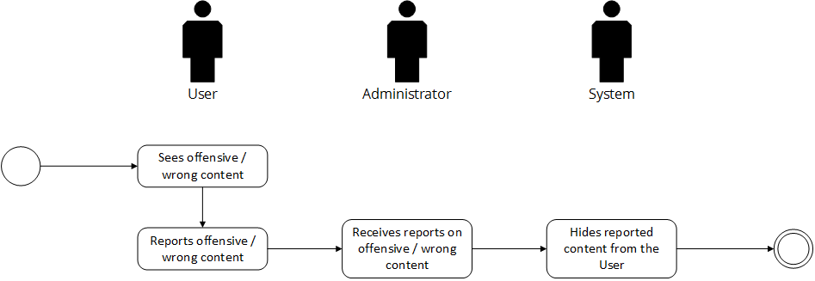

Post-conditions: Successful: The Eventi homepage has successfully loaded and the events are shown. The reports yielded satisfactory administrative judgement results.
Failed: The website did not load.

Special Requirements: NONE

